**Project Development Phase**

**Sprint 1**

|  |  |
| --- | --- |
| Date | 25 October 2022 |
| Team ID | PNT2022TMID41225 |
| Project Name | Global Sales Data Analytics |

**Sprint 1 tasks:**

* IBM Cloud Account creation
* IBM Cognos Account creation
* Fetch Data from external API
* Downloading dataset
* Data Collection
* Understanding dataset
* Create Data module
* Uploading dataset
* Login page creation

**IBM Cloud Account:**

Creating and login to IBM cloud account.

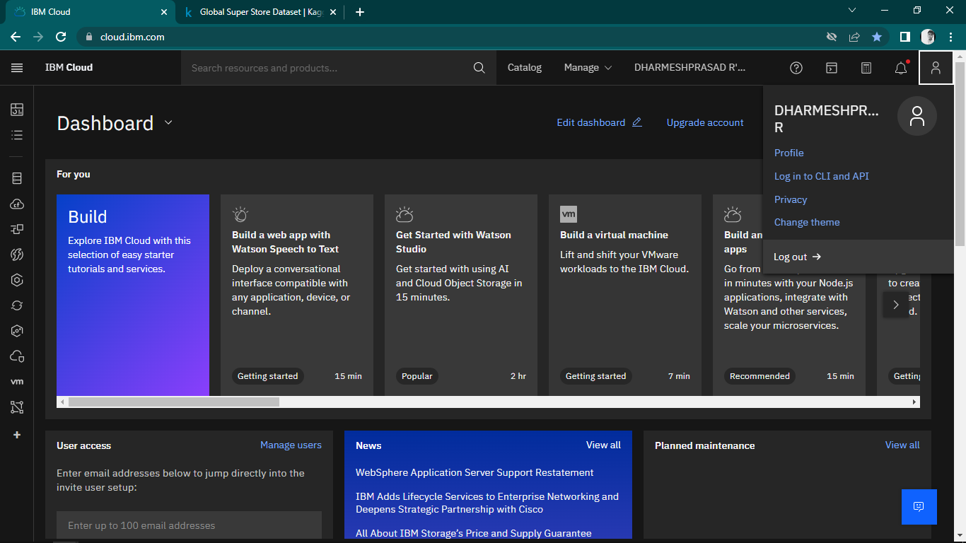

**IBM Cognos Account:**

Creating and login to IBM Cognos account.

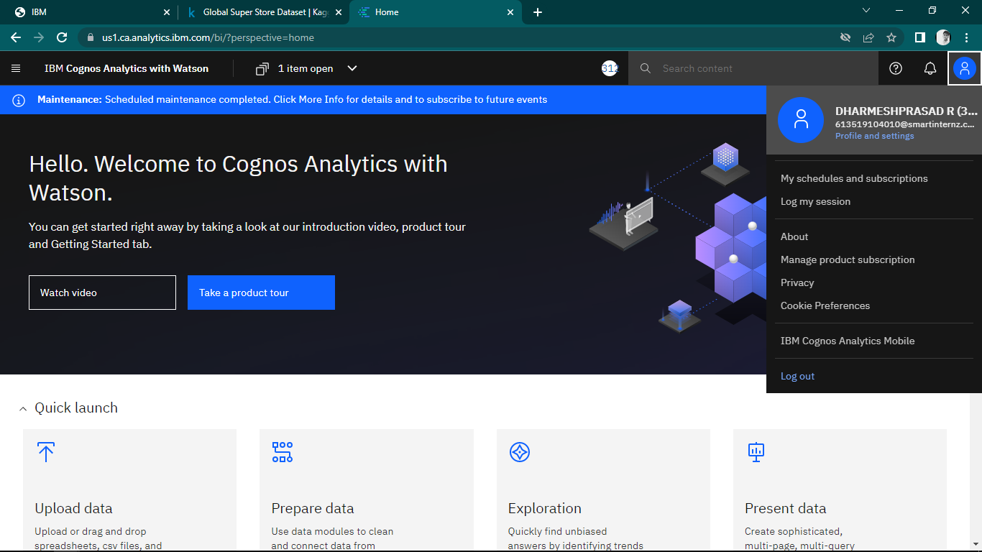

**Fetch Data from external API:**

Fetching data from external kaggle API

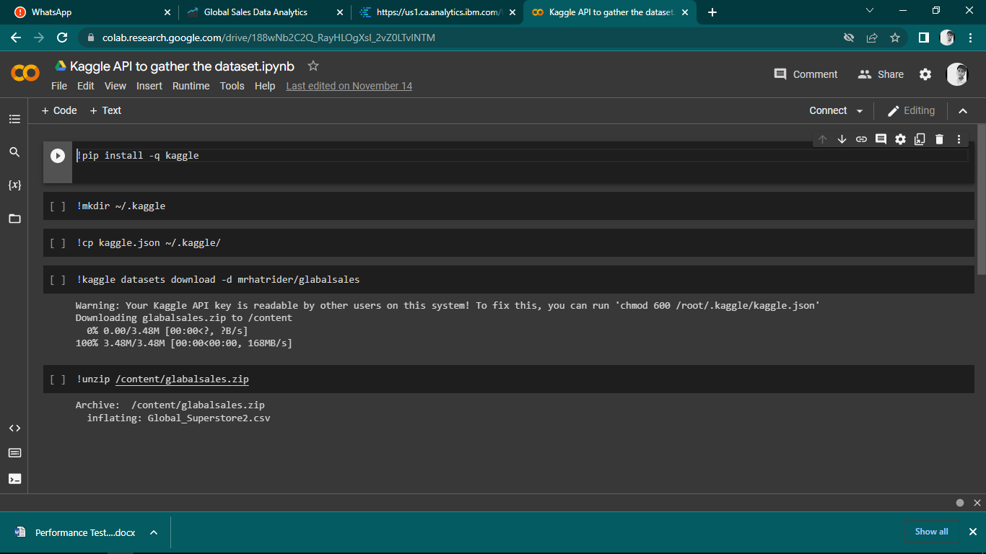

**Downloading Dataset:**

Downloading Global super store dataset from kaggle.

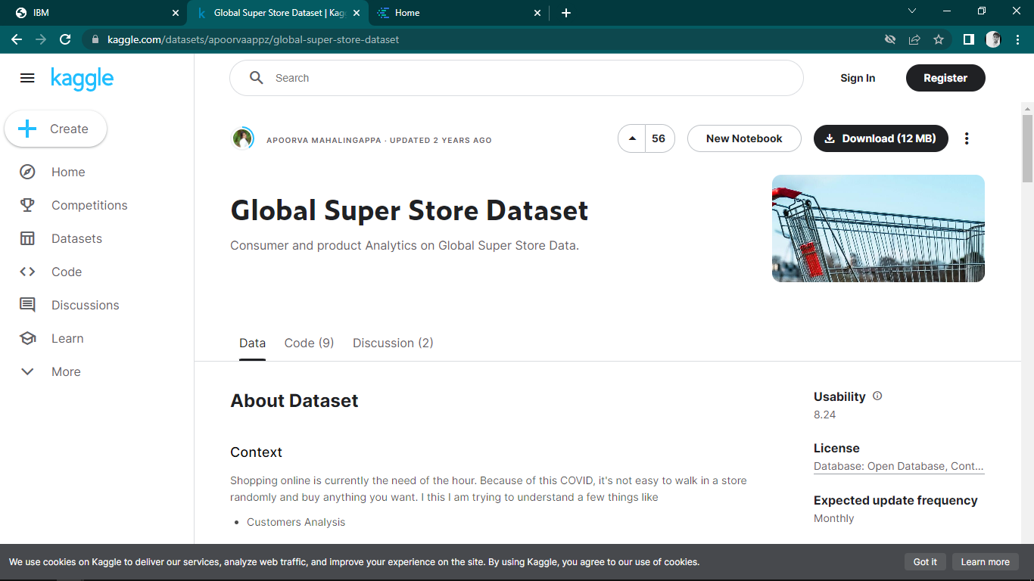

**Data collection:**

Understanding the dataset and analysing the data requirements.

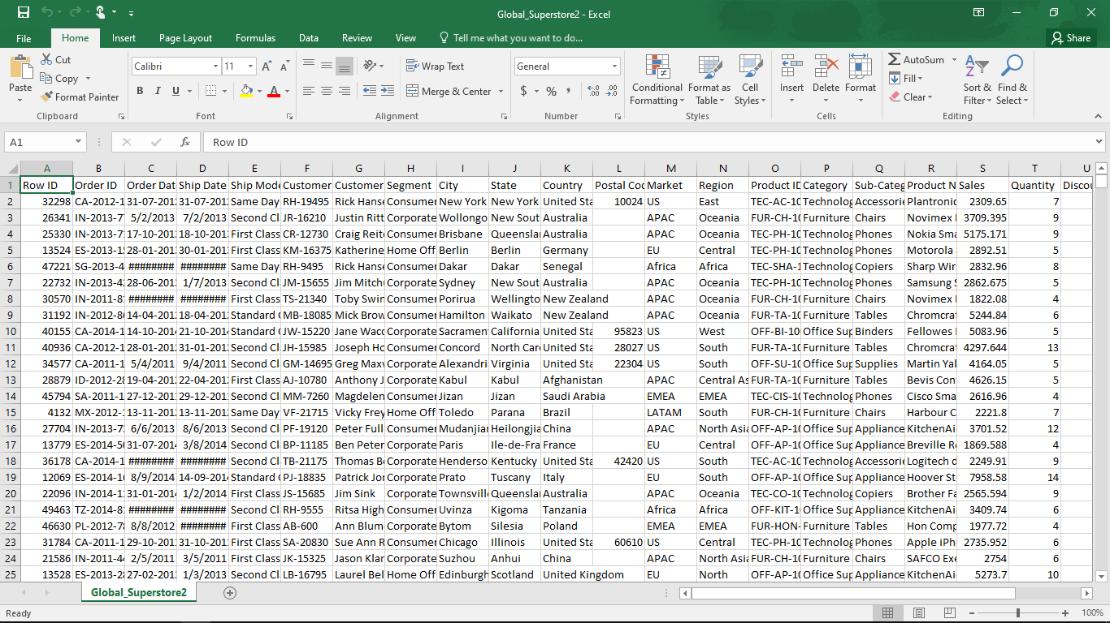

**Understanding the Dataset:**

The dataset contains the details of the order done online by people across the globe in the time frame 1-jan-2011 to 31-dec-2014.

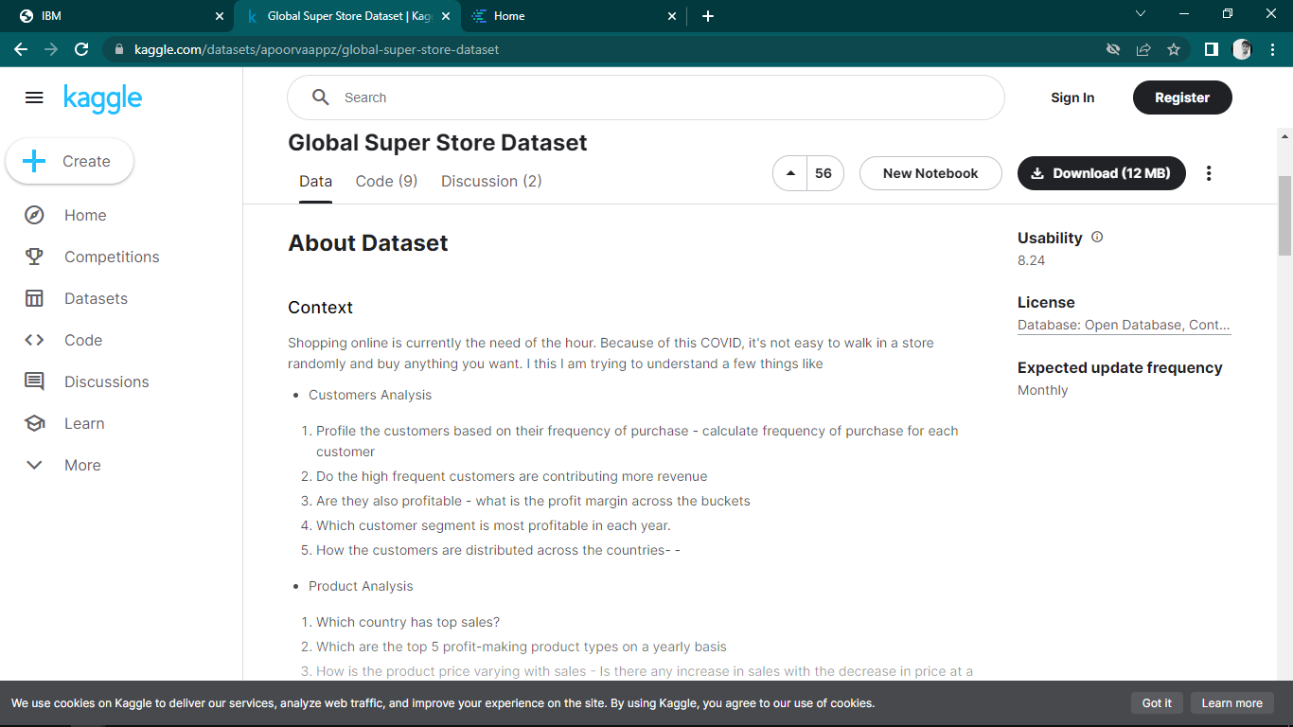

**Create Data module:**

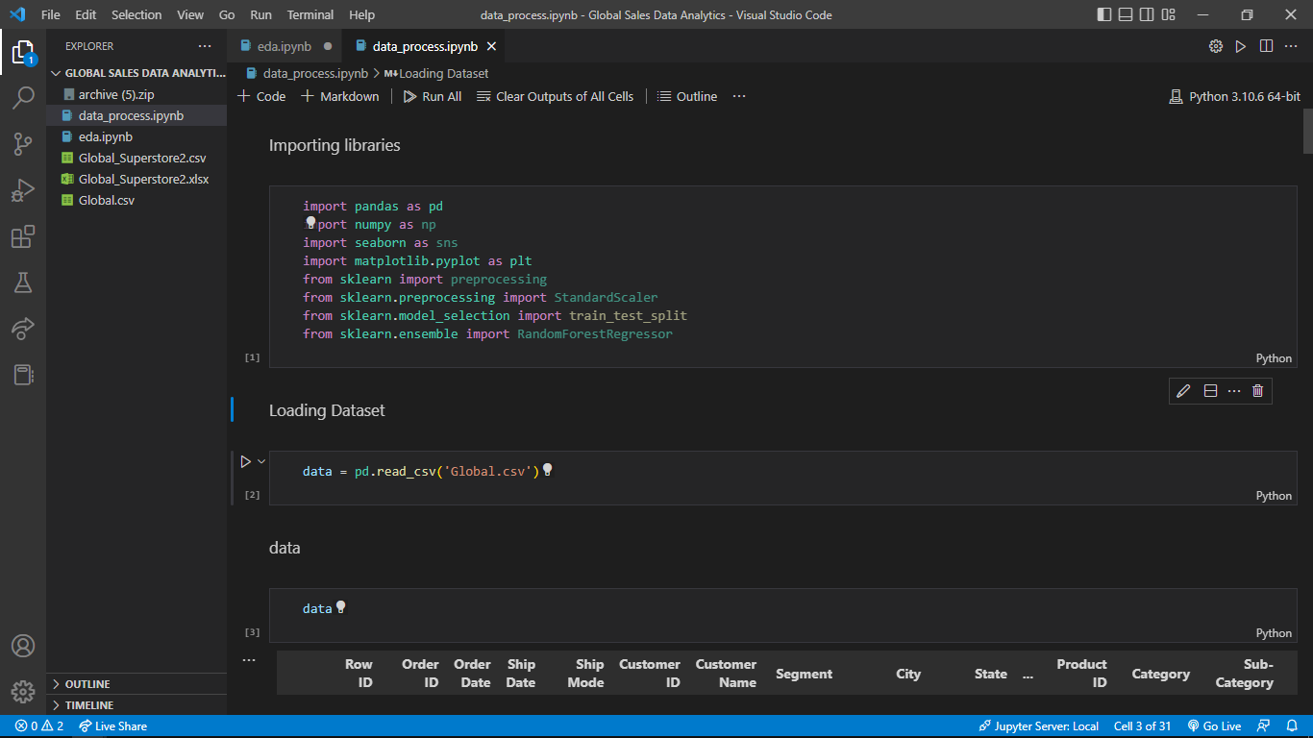

**Uploading dataset to IBM Cloud:**

Uploading dataset into IBM cloud.

Using IBM Db2.

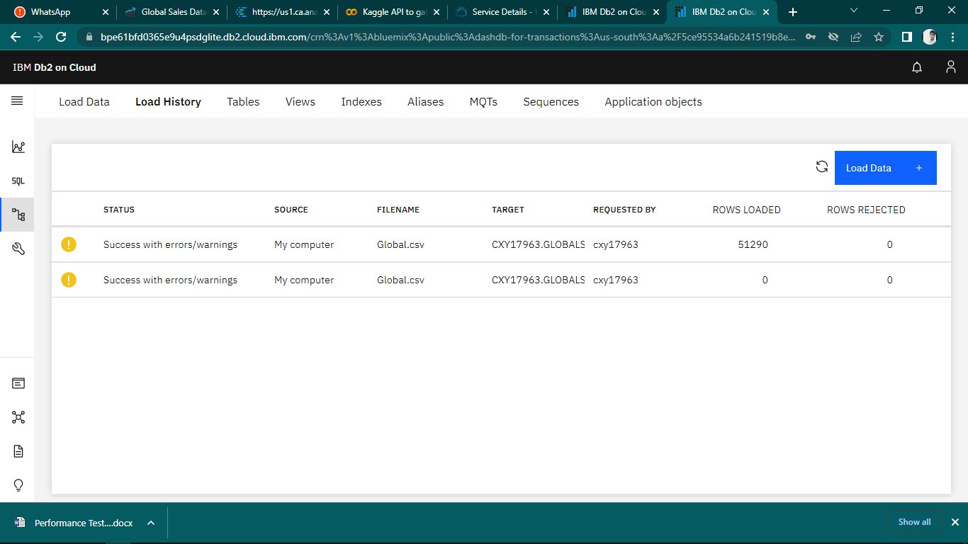

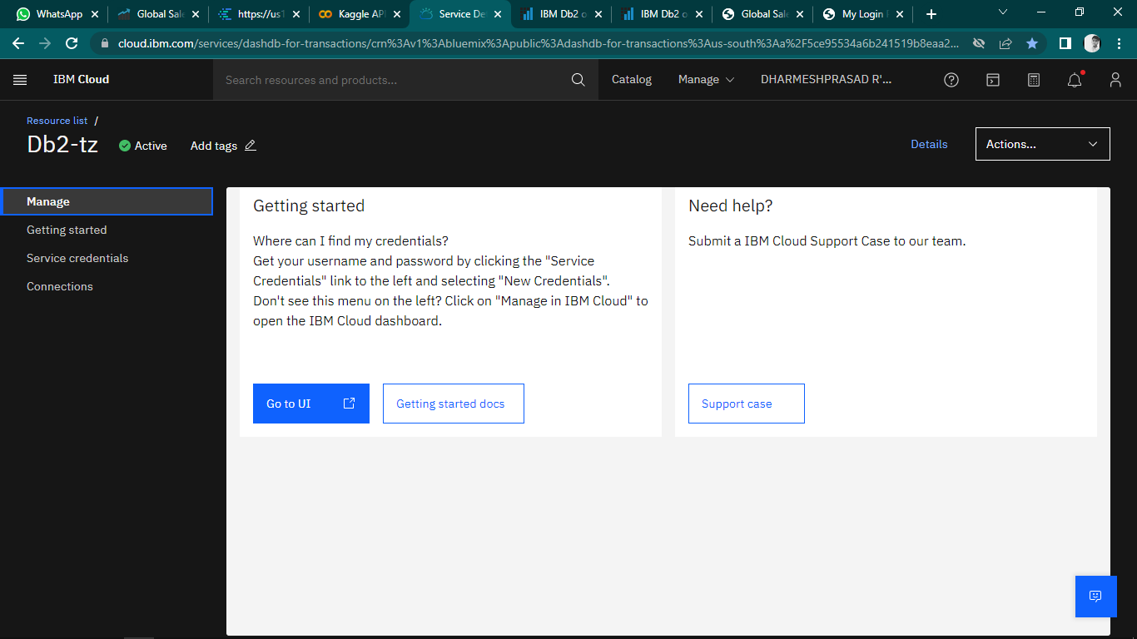

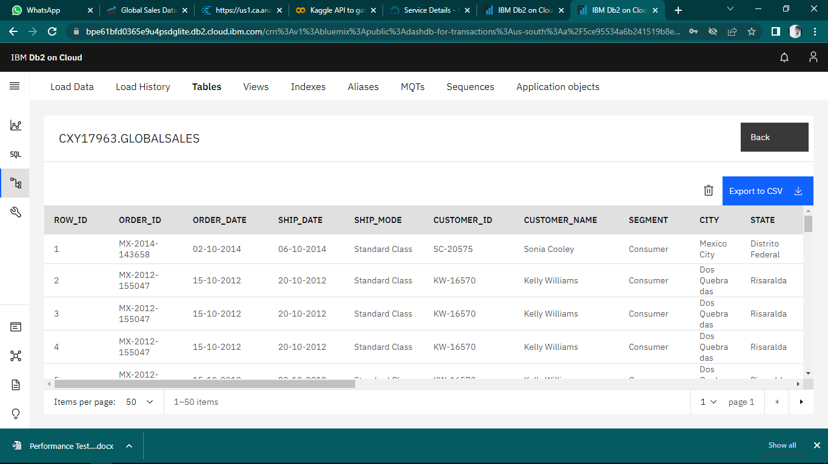

**Login page creation:**

